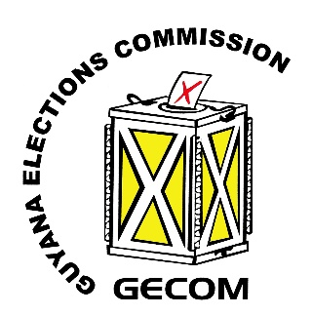**Press Release**

**Only the High Court has Exclusive Jurisdiction to Determine whether an Election has been Lawfully Conducted.**

**28th November, 2024 GEORGETOWN** – The Guyana Elections Commission (GECOM) is once again faced with the challenge of frequently repeated disinformation being peddled in the public domain by prominent political stakeholders and activists using various platforms. The most recent one being a case in which, Dr. David Hinds of the Working People’s Alliance (WPA) used his Politics 101 talk show on Monday 25th November, 2024 to accuse the GECOM Chairman of ‘cover up of fraud.’

During the programme, while referencing **allegations** of voter impersonation that surfaced during the National Recount exercise in 2020, Dr. Hinds specifically accused the Chairman of GECOM, Justice Claudette Singh of “declaring an election with knowledge of the potential breach of the law” and voting against an internal review of the 2020 General and Regional Elections. In this regard, while GECOM has continually and categorically clarified that, in accordance with the Constitution, the Commission does not have the authority to validate any elections, there is a relentless effort by a few individuals with malicious intentions who continue to repeat such a false narrative.

Consequently, as the agency responsible for the conduct of elections in Guyana, it is mandatory for GECOM to ensure that the public is always accurately guided insofar as statutory provisions are concerned. It is, therefore, against this backdrop that the Commission takes the opportunity, once again, to dispel the disinformation being spewed in the public.

*Article 163 (1) (b) (i) of the Constitution, which is the supreme law, provides that* ***“the High Court shall have exclusive jurisdiction to determine any question either generally or in any particular place, an election has been lawfully conducted or the result thereof has been, or may have been, affected by any unlawful act or omission.”***

It is of crucial importance to note that, notwithstanding GECOM had received copies of documents associated with the alleged voter impersonation, the Commission could not have investigated this issue since, according to Article 163 (1) (b) of the Constitution, the only method by which such a matter could have been ventilated is specifically stipulates as by way of an election petition.

In view of the foregoing Article of the Constitution, there is absolutely no way that GECOM should be accused of ‘cover up of fraud’ as is the case in point.

Accordingly, the GECOM encourages all stakeholders to ensure that they conduct thorough legal research before publishing false information in the public, since this type of misinformation and disinformation carry potential to cause mistrust and lack of confidence in the Commission and harm to its Officials.

***

For media queries, please contact:

Ms. Yolanda Ward

Public Relations Officer

Guyana Elections Commission

pro@gecom.org.gy | 225-0277-9 Ext 187